The NT user needs to be added to [VM236].[WMProfitKey].[ssrs].[StartParameter]

To scan Released with a start location

Open the Scan_Shell_to_Release Report and follow the screen shots below.

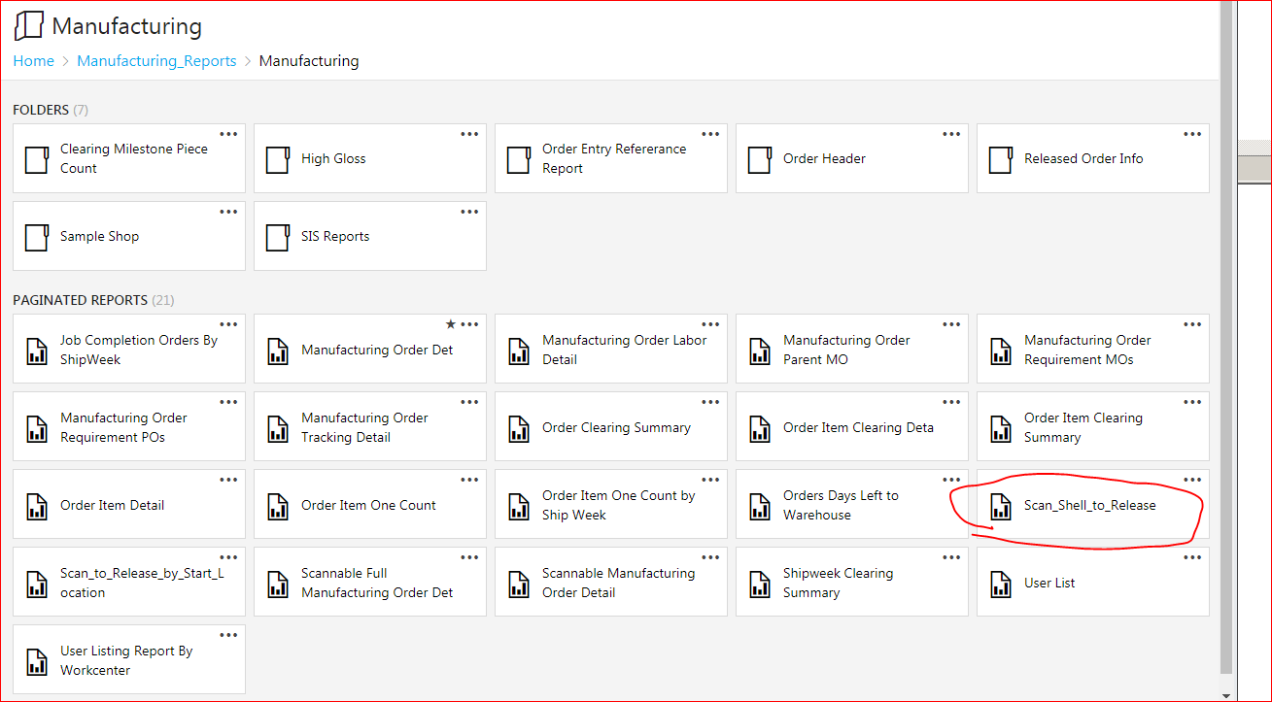

Click on the drop down arrow.

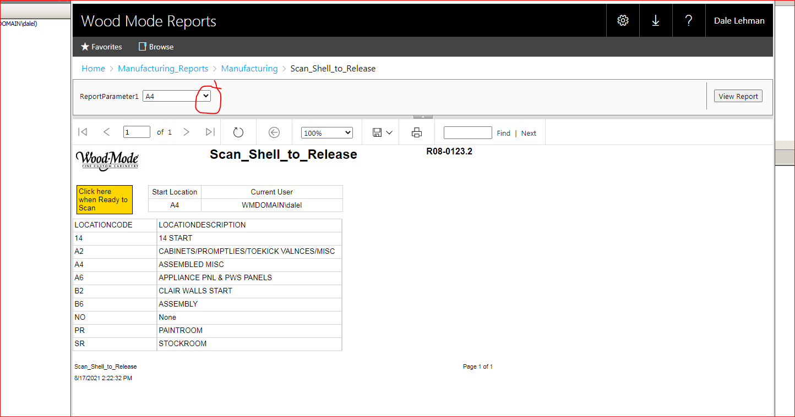

D

Choose the location from which the order is to start.

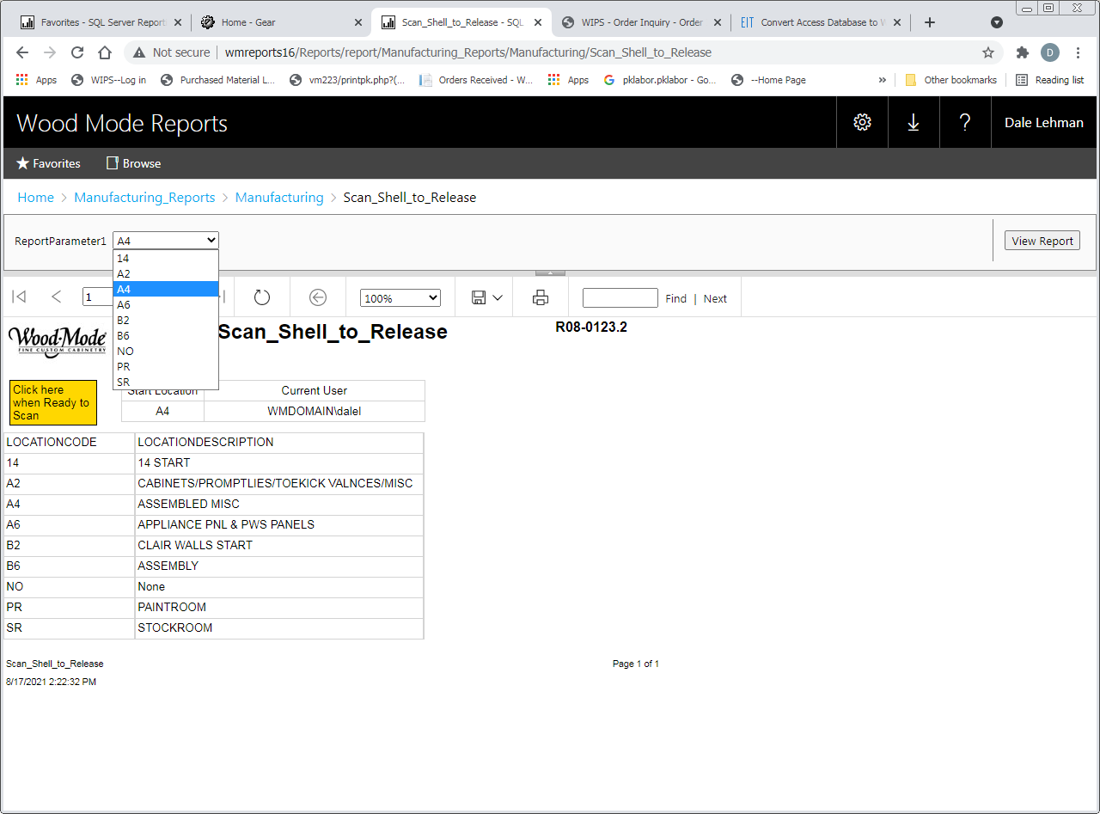

1. Click the view report button to set the chosen location.
2. Click on the “Click here when Ready to Scan”

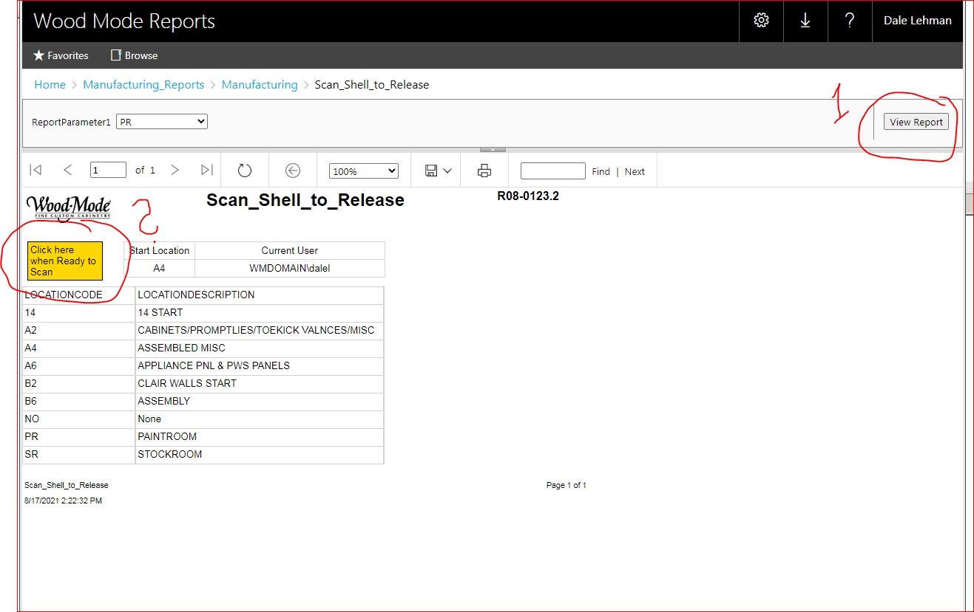

In order for the scanning to be seamless there needs to be a programmable scanner used. Scan the bottom bar codes in order.

The bar code will program tabs into the scan so that it won’t need done manually with each scan.

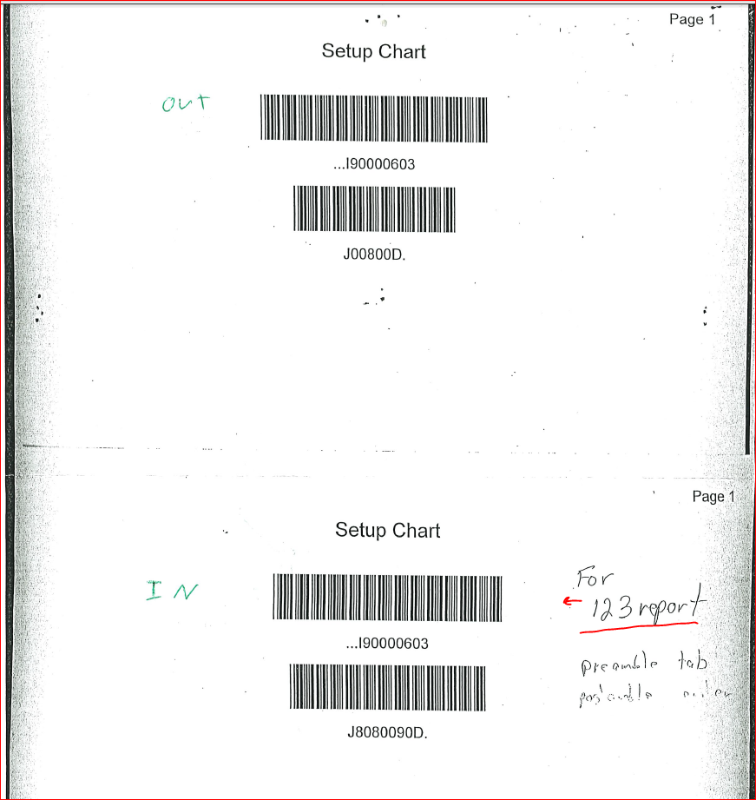

Start Scanning

